Populate memory items for feedback from host
Memory and register filling for Boolean flags, triggers or coefficients for some operation is handled here. Controllers from host are transferred and stored into memory blocks.
Figure 1 Populate memory items for feedback from host

AIO settings
Purpose of this loop is to fill registers to assign input output inversion/noninversion, piezo/photothermal mode ORT, excitation enable/disable, fast io enable/disable, fast io clock dividers, height limits for Z signal and set AI voltage range.
Figure 2 AIO settings

Analog inputs acquisition
This loop samples all the analog input channels, writes to an array and pass it to a FIFA (aio.t.input). Note that analog input sampling rate of NI USB 7856R is 1MSPS.
Figure 3 Analog inputs acquisition

Analog inputs sorting
This loop divides the analog inputs that are transferred via aio.t.input into other FIFOs. It is a single cycled timed loop but note that output valid of aio.t.input triggers the next actions at 1MHz rate.
- AI0 and AI1 are inputs for horizontal and vertical deflection. Two of them are bundled and written into aio.t.slowHorizVert. This FIFO will be read in Input module acquisition and excitation output loop. They are also written into controllers aio.s.slowVertical and aio.s.slow.Horiz.
- AI2 is used for sum input and written into indicator aio.s.sum.
- The rest of inputs are written into an array and passed to FIFO aio-hdt.aux and indicator aio.o.inputs. aio-hdt.aux is used as auxiliary host data transfer (imaging) channel input and aio.o.inputs is used to scope the inputs on the host side (at low speeds).
- aio-hdt.aux.selector FIFO is used to transfer the array that has all the channels to host via imaging channels.
- aio-hdt.x has X (AI4) and Y (AI5) sensor inputs and is used to pass them to scan loop as an input to XY PID.
All the inputs go through invert_and_blank_caseStruct.vi before written into a FIFO. This vi inverts or buffers its input based on the dedicated Boolean on aio.o.invertInputs register.
When Aio.vd.corr is true, a correction is applied to AI0 (when used as a vertical deflection input channel), subtracting a value that is previously stored in a memory block (aio.deflection.corr) to the actual read AI0 sample value. This correction is applied to remove the effect of the cantilever Z position on the vertical deflection signal (AI0). A previous calibration of this effect is performed and stored in the memory block aio.deflection.corr, where for every cantilever Z position a value of the vertical deflection is saved. The actual Z position value (from the aio.vd.corr FIFO) is used to extract from the memory block the value for the correction.
Figure 4 Analog inputs sorting

x-y physical output
This loop writes calculated X and Y outputs to the analog output channels, AO0 and AO1. Transferred data via se.t.outXYInt passes through invert_and_blank_caseStruct.vi to invert or buffered according to the boolean stored in aio.o.invertOutputs.
Figure 5 x-y physical output

Slow host-controlled signal generator
This loop writes on analog output channels AO4-7. aio.o.outputs controller is sent by the host, so it allows only slow signals such as DC bias signals. For AO5-7 it is possible to write the data that is generated by the loop named Write a Sawtooth Waveform to 3 FIFOs (Stick-Slip). The sawtooth waveform generator is programmed to drive a particular positioner. Other waveform types can be implemented if needed.
Figure 6 Slow host-controlled signal generator

Height and excitation output
This loop writes calculated height and excitation outputs to the output channels AO2 and AO3. Transferred data via aio.t.slowHeightDrive passes through invert_and_blank_caseStruct.vi to invert or buffered according to the Boolean stored in aio.o.invertOutputs. Single cycled timed loop runs at 40 MHz until there is a data in the FIFO. The first valid data from aio.t.slowHeightDrive terminates the timed loop and data is sent to AO2 and AO3. Then the same loop starts again. Please note that analog output sampling rate of USB 7856R is 1 MSPS.
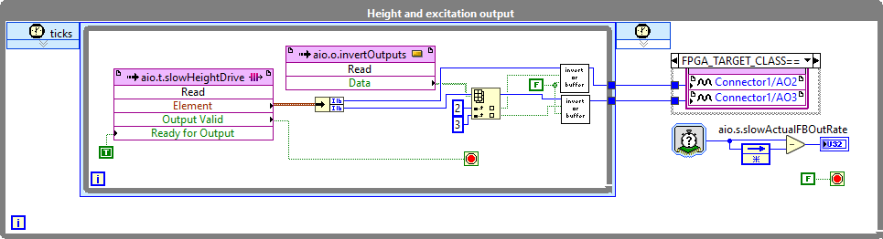
Figure 7 Height and excitation output

Fast ADC DAC interface
This loop is the interface of the external ADC and DAC electronics. DAC has 14 bits resolution and ADC has 16 bits resolution. The clock is set by a circular counter. At every pulse of the counter the clock changes its state. Therefor generated clock is 160 Mhz/(2*aio.p.fastADCclockdec).
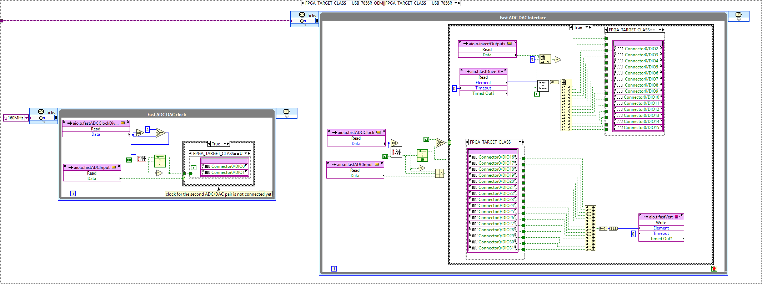
Figure 8 Fast ADC DAC interface

Input module acquisition and excitation output
Inputs of different imaging mode loops is written in this loop. Moreover, excitation output is also transferred from relevant source to the output channel. For input and output there are two options. The first pair uses 1MSPS builtin channels of the FPGA (aio.t.slowHorizVert and aio.t.SlowHeightDrive). The second pair uses external DAC and ADC chips which can run up to 20 MHz (aio.o.fastVert and aio.o.fastOut). This loop runs at 40MHz but the actions are triggered by the input data transfer rate (1MHz for built-in channels, up to 20 MHz if fastInput is enabled)
ORT: Every single vertical deflection input (aio.t.slowHorizVert [0] or aio.t.fastVert) is assigned an index number from 1 to ort.waveSize. Every received input, triggers a write action from memory, aio.excxittation, to the excitation output (aio.t.slowHeightDrive and aio.t.fastDrive). Therefore, syncronization between input and output is achieved.
Circular counter (circularCounter_v2.vi) counts up to ort.waveSize at every valid input (aio.t.slowHorizVert or aio.t.fastVert). Current number is the index number of received data and address of the next excitation output. When the maximum number (ort.waveSize) is reached circular counter (circularCounter_v2.vi) creates a pulse and this triggers a handshake, aio-ort.t.endOfCycle, with loop ORT mode.
Tapping: Incoming vertical deflection data (aio.t.slowHorizVert [0] or aio.t.fastVert) is written into aio.t.lia.input to transfer the data to the lock-in function. Generated excitation output by DDS is transfered from lia.output to excitation output (aio.t.slowHeightDrive and aio.t.fastDrive).
Contact: Vertical deflection input (aio.t.slowHorizVert [0] or aio.t.fastVert) is written in aio.t.contactModeIn.
Aux: Horizontal deflection input (aio.t.slowHorizVert [1]) is written in aio.t.aux
New mode: If you want to implement a new mode you can send the input data to aio.t.newMode and follow the dedicated loop (#New mode#).
ThermalTune: Vertical deflection input (aio.t.slowHorizVert [0] or aio.t.fastVert) is written into aio.t.thermalTune with the option of downsampling. Circular counter counts up to thermalTuneDownsampler at every valid input and generates input valid for aio.t.thermalTune when maximim is reached.
Figure 9 Input module acquisition and excitation output

ORT Mode
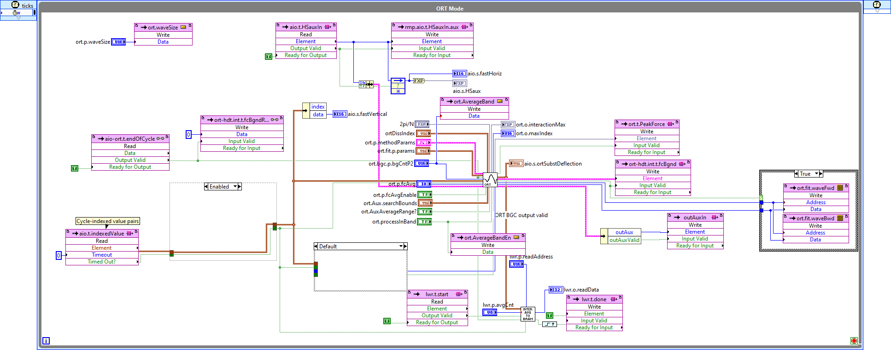
Figure 10 ORT Mode
This loop handles ort mode operation. Indexed input is sent to ort_main.vi. Peak force output of ort_main.vi is transferred to the PID loop via ort.tPeakForce as the process variable.
Ort.hdt.int.t.fcBgnd is used to transfer the background to the host.
Figure 11 ort_main.vi
The first action in ort.vi is background correction. By doing so tip-sample interaction is acquired. Data passes into ort_bgc_main.vi and previously saved background is subtracted from the new data.
Figure 12 ort_bgc_main.vi
ort_bgc_main.vi not only subtracts the background data but also records the background into memory with BGND AVG TO BRAM vi. It averages given number of ort cycles and writes into memory block named ort.bgc.average.
Subtracted data passes to ort_find_max.vi. This vi searches for the max force with three different methods. The first method, syncMaxWithAverage.vi., averages the last numbers in the given window size (ort.p.winSizeP2) and searches for the maximum value. This method is used to reduce the noise in the interaction. The second method (asyncMaxWithAverage.vi) averages all the numbers in the given window, it doesn’t search for the maximum point. The third one (asyncMaxSearch.vi) searches for the maximum point in the given window without averaging.

Figure 13 ort_find_max.vi
ortMaterialProp.vi calculates the approach and retract slopes (fb-hdt.t.fwdSlope, fb-hdt.t.bwdSlope), min values on approach and retract (ort.ApprMinValue, ort.RetractMinValue, fb-hdt.t.minBwd is used to send retract minimum value as one an image channel), dissipation (fb-hdt.t.Dissipation).
- Dissipation: Net area under force displacement curve is calculated. Since the excitation is a cosine wave accumulation of the cantilever deflection is not enough. Instead, deflection should be multiplied by Δz, which is the derivative of the excitation.
- Min values: Minimum values are searched between the peak force point and the minimum and the maximum interaction boundaries selected by the user (ortDissIndex).
- Slopes: Both for the approach and retract, integration of deflection and the integration of the cantilever motion in between the minimum deflection point and maximum deflection point are used to calculate the slope.
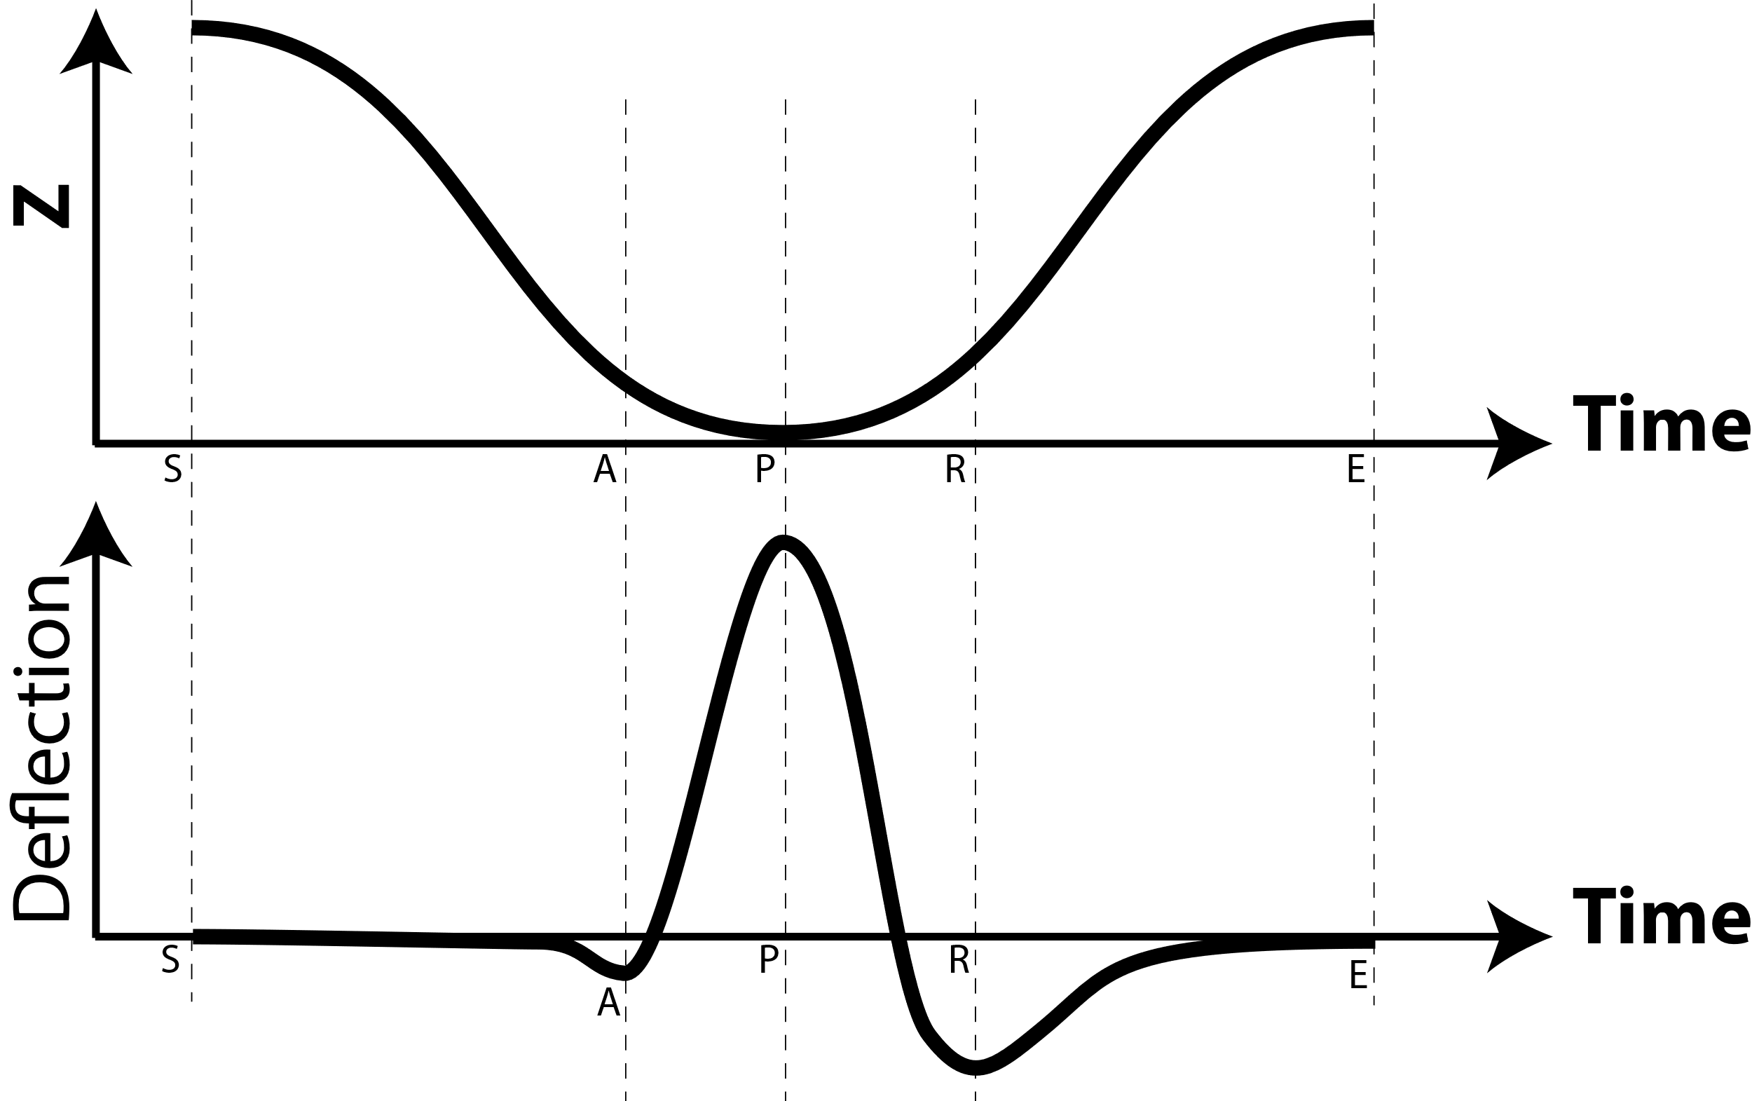
Figure 14 ORT excitation and interaction curves
Following equations show the math behind dissipation and slope calculation. Highlighted parts are constant for a given excitation signal. Therefore, they are calculated and stored in the memory when the excitation signal is generated.

Dissipation:
$$Dissipation=\sum_{i=S}^{E}{Defl\left(i\right)*\left(z\left(i\right)-z\left(i-1\right)\right)}$$
$$z\left(i\right)=1+\cos\left(i*\frac{2π}{N}\right), where N is the number of points in the excitation \\ z\left(i\right)-z\left(i-1\right)=∆z\left(i\right)=-\operatorname{sine}\left(i*\frac{2π}{N}\right)*\frac{2π}{N}$$
This gives a value between 0 and 2. It just needs to be multiplied by the peak-peak amplitude (nm) and divided by 2. This is handled on the host side.
$$Dissipation=\sum_{i=S}^{E}{Defl\left(i\right)*(-\operatorname{sine}\left(i*\frac{2π}{N}\right)*\frac{2π}{N})}$$
Note that, the deflection needs to be converted to force (multiplied by deflection sensitivity and spring constant). This conversion is also handled on the host side.

Approach slope: P>i>A
kAppr=DeflP-DeflAzP-zADefli=DeflA+kA*zi-zAi=APDefli=P-A*DeflA+kAppr*{P-A*-zA+i=APzi}kAppr={i=APDefli}-P-A*DeflAP-A*-zA+i=APzii=APzi=i=AP1+cosi*2πN=P-A+{sini*2πN*N2π}sini*2πN*N2πAPi=APzi=P-A+sinP*2πN-sinA*2πN*(sini*2πN*N2π)
kAppr={i=APDefli}-P-A*DeflAP-A*-zA+P-A+0-siniA*2πN*N2π
kAppr={i=APDefli}-P-A*DeflA-cosA*2πN(P-A)-sinA*2πN*N2π

To calibrate the slope data we need to multiply it by the deflection sensitivity and divide by the amplitude/2.
Deformation
kAppr=[DeflD-DeflA]d+[DeflD-DeflA]
d=DeflD-DeflA*1kAppr-1

DMT Modulus (source: Dokukin and Sokolov, 2012)
FL=43E*R*i32+Fadh
With F the force, E* the reduced Young modulus (E* = E/(1-v²), R* the reduced radiuce (1/R* = 1/R_{tip} + 1/R_{surface}) and i the indentation depth (deformation).
E*=34F-FadhR*i3/2 =34F(R*)-0.5i-1.5

AM mode
This loop has two main functions. dds.vi generates excitation output and sine and cosine reference waveforms for lock in by using direct digital synthesis. lia.output is the FIFO that carries excitation waveform to Input module acquisition and excitation output loop.
am_lockin.vi is a lock-in implementation. Acquired input is demodulated with sine and cosine waveforms that are generated in dds.vi. Two stage Cascaded-Integrator-Comb-Filter (CIC_stage.vi) is used as low pass filter. Decimation factor for these filters have to be power of two. Log2(decimation factor) is sent to two stages via lia.lpf.dec1 (2^n) and lia.lpf.dec2 (2^n).

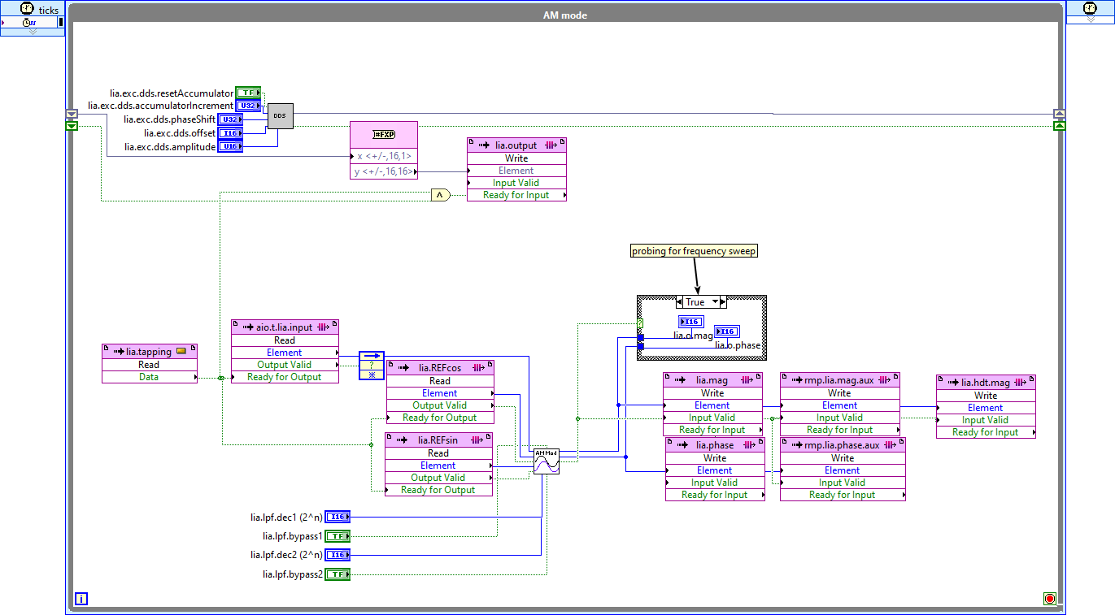
Figure 15 AM mode
Figure 16 am_locin.vi

Contact mode average
This loop is used in contact mode. It has Cascaded-Integrator-Comb-Filter (CIC_stage.vi) to down-sample the input. Note that decimation factor for the filter has to be power of two and the input (aio.i.downSamplingAverager) is the log2(decimation factor).
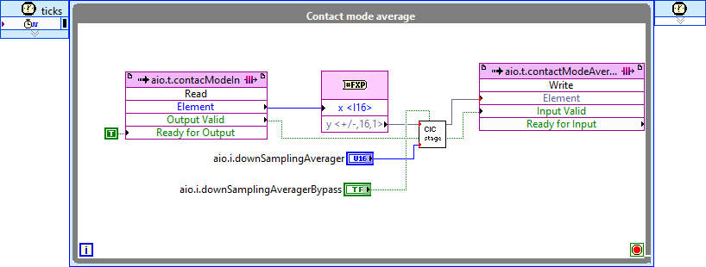
Figure 17 Contact mode average

ORT mode excitation generator
This loop generates excitation signal for ort mode using point per clock strategy. For the desired excitation frequency and sampling frequency, points in one waveform is stored in the memory (aio.excitation) and sent one by one. Waveform options are sine, triangular, square, and sawtooth.
In order to calculate the physical properties in the ort mode, excitation (displacement in Z) related information is needed such as derivative of the waveform or the index number of the maximum point. This information is also prepared and stored in this loop when the excitation is updated.
Figure 18 ORT mode excitation generator

Main process variable selection
Here the main process variable for PID loop is selected based on the imaging mode. The options are contact mode, ort mode, aux mode, tapping mode.
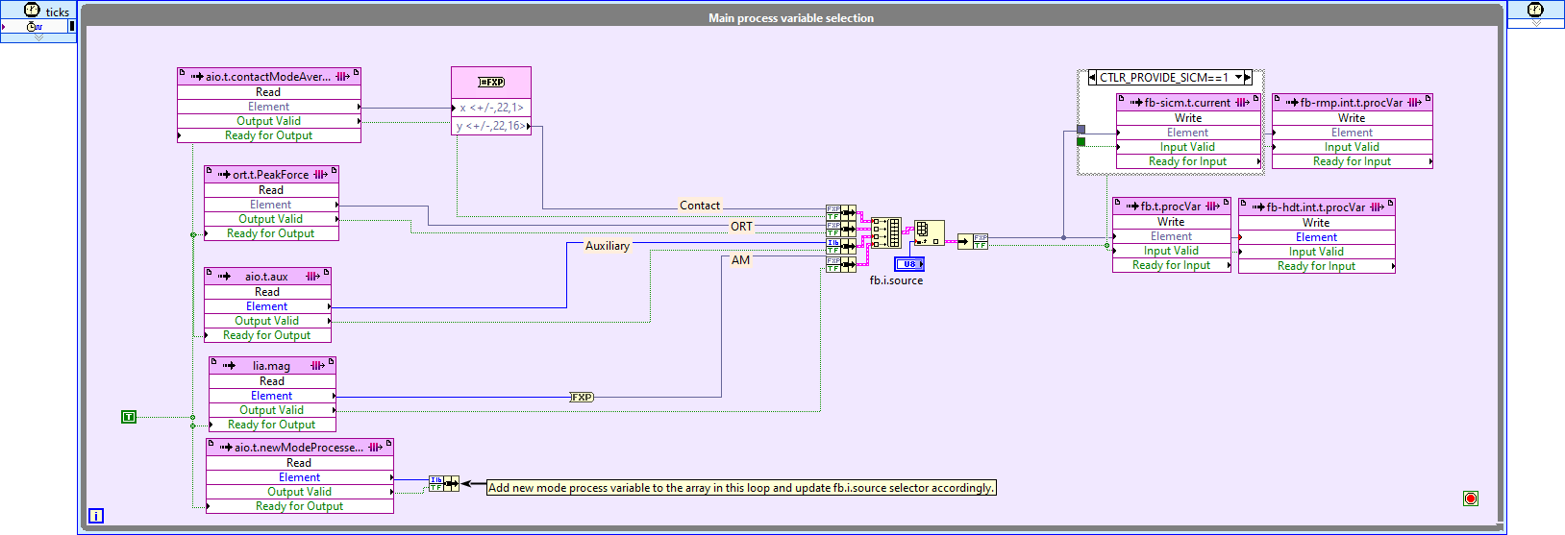
Figure 19 Main process variable selection

PID calculation and height control
This loop generates the height signal based on the process variable. The following block diagram shows all the operations done on the input until it generates the output.
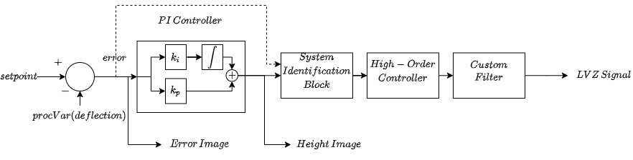
Figure 20 Block diagram of the PID calculation and height control
As observed in the code, the input signal is carried in the FIFO fb.t.procVar which goes into a VI called QNM PID. This VI is equivalent to the PI controller in Figure 20. The output of this VI is then sent into a VI for system identification (SID MAIN). The output of the system identification is then sent to the high-order controller block (SOS 8BLK) and then passes through a custom filter (SOS 4BLK). Each of these blocks is discussed in details.
Figure 21 PID calculation and height control
PI Controller
This VI (pid_main.vi) is not just responsible for the PID operation, it also controls the manual commands that are sent from the host. Its input signal is the deflection (process variable) and its main outputs are error and heigth signal. The next figure shows the block diagram of this VI. There are several controls that are fed into the VI to control its operation:
fb.p.params : contains the setpoint, and proprtional and integral gains
fb.mot.p.params : contains parameters for the manual motion of the actuator
fb.p.limits : contains the upper and lower limits to saturate the prepared control signal
fb.loff.p.params : contains parameters for the lift-off of the actuator (in case of background correction in ORT mode)
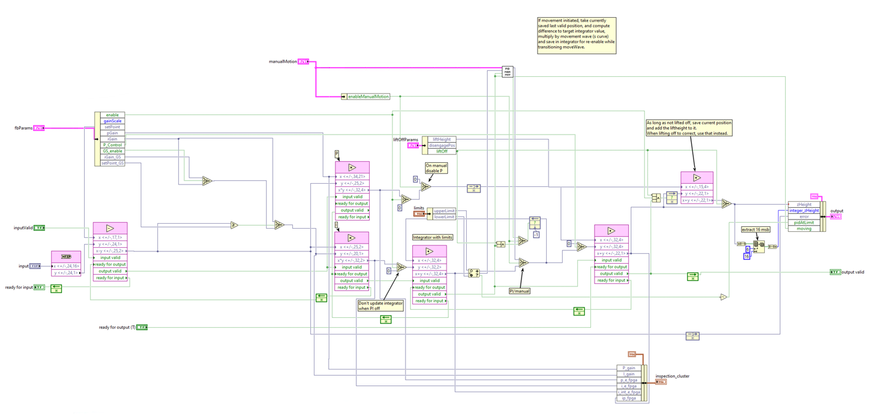
Figure 22 Block diagram of pid_main.vi
Input is the process variable, and it first passes through a subtraction block in which it is subtracted from the setpoint to form the error signal. The error signal then passes through two parallel paths in which it is multiplied by a proportional (pGain) and an integral gain (iGain). After the inetgral gain multiplier, an adder sums up the current data with the one from last cycle; in total, it acts as an integrator.
The two signals are then added and sent to the output of the VI togetehr with the error signal. Note that in this description, there was no manual motion. The rest of the blocks that are placed on the top side of the VI are responsible for the manual motion of the Z actuator. They overwrite the PI output based on the parameters that are sent from the host (manualMotion).
System Identification
This VI (sid_main) is responsible for sending a Pseudo Random Binary Sequence (PRBS) to the actuator to identify its dynamics which is used in LAController VI on host side. This means that in normal SPM operation (scanning a sample topography), this VI is bypassed. When it is used, it cuts the signal line and overwrites it. Note that the line of signal always passes through this VI, but it is not always active. The controls that manage this VI from the host side are:
sid.p.params : contains the details of the identification signal
sid.p.idSource : this chooses which signal is used as the identification input (closed-loop or open-loop identification)
The following figure shows the block diagram of this VI:
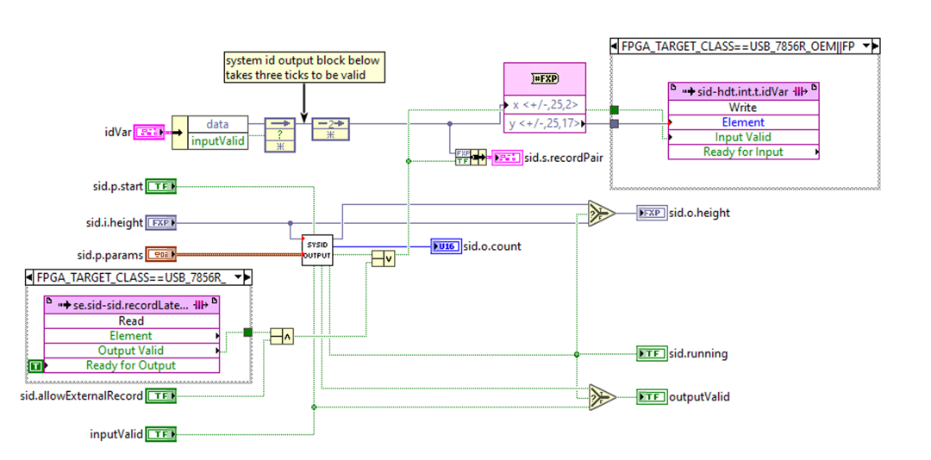
Figure 23 Block diagram of sid_main.vi
The FIFOs (se.sid-sid.recordLateral and sid-hdt.int.t.idVar) inside the VI are used to transfer data between host and target when the VI is in action.
High-Order Controller
This part of the code is used to filter the height signal based on the dynamics that are designed in the LAController VI on the host. This Vis (flt_sos8xblock.vi) input and output are the height signals before and after filtering. There are three main parametrs that regulate its functionality.
flt.bypass1 : an array of booleans that activate/deactivate the blocks inside the VI
flt.p.anot8x : an array of size 16, which has 8 pairs of parameters that correspond to the denominator coefficients of the filters
flt.p.b8x : an array of size 24, which has 8 pairs of parameters that correspond to the numerator coefficients of the filters
The following figure shows the block diagram of this VI:
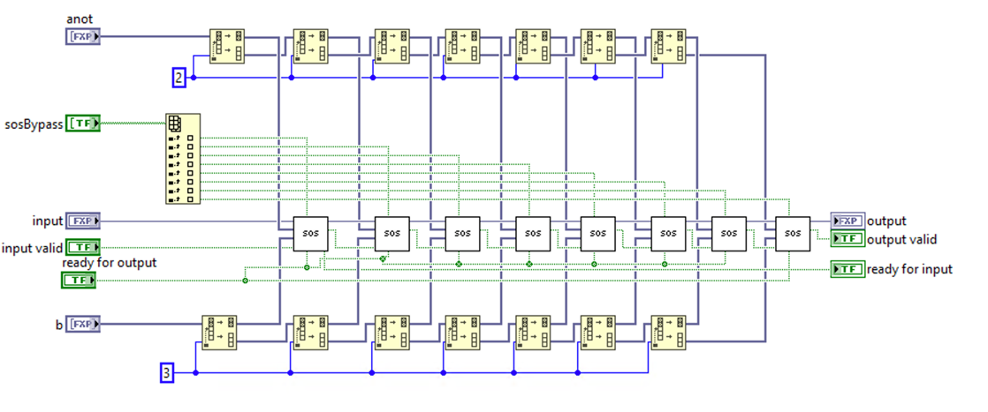
Figure 24 Block diagram of flt_sos8xblock.vi
As seen in the figure, it consists of 8 similar blocks (sos.vi) each of which can be used to create the dynamics of a second-order-system (SOS). There are no FIFOs involved in this VI and it is easily replicable to anywhere that needs linear dynamics added to the signal. In this VI, anot has the coefficients for the denominator of the second-order blocks and b has the coefficients for the numerator of the dynamics.
Custom Filter
This VI (flt_sos8xblock.vi) has a strucutre similar to the high-order controller with the difference that it has fewer number of SOS blocks. It is used to run custom filters (low-pass, high-pass, or band-pass) on the output signal. The parameters that control its functionality are:
flt.bypass2 : an array of booleans (4) that activate/deactivate the blocks inside the VI
flt.p.anot4x : an array of size 8, which has 4 pairs of parameters that correspond to the denominator coefficients of the filters
flt.p.b4x : an array of size 12, which has 4 pairs of parameters that correspond to the numerator coefficients of the filters
The following figure shows the block diagram of this VI:
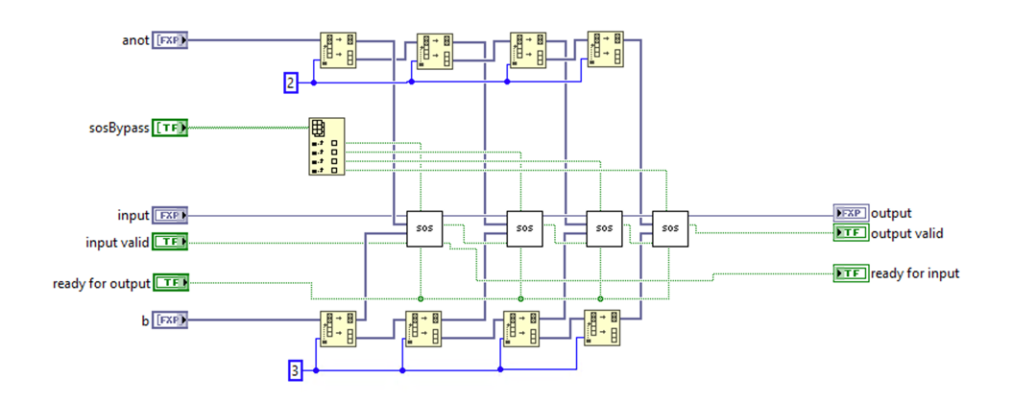
Figure 25 Block diagram of flt_sos8xblock.vi
The whole PID Calculation and height control loop runs at the target base clock. However, the signal gets updated only when the input signal (fb.t.procVar) is valid. This point can be seen in the fact that all the blocks inside the loop are connected together with handshaking. A new output will be prepared only when a new input is ready.
In the block, there are two points where the signal is written into FIFOs. These two FIFOs are fb-hdt.t.error and fb-hdt.t.height which contain error and height signal, respectively. These two FIFOs are used to create the height and error channels of the image.
Ramp watchdog
Figure 26 Ramp watchdog
It defines the parameters to stop the ramp in case one of the channel signals rmp.p.safeTipTriggerChannel (vertical deflection, amplitude, phase, error, etc.) are higher or lower (depending on the user selection rmp.p.safeTipSign) than an specific set point value rmp.p.safeTipRamp_SetPoint. This watchdog is used for tip safety, to stop the ramp in case a specific signal value shows a probability of damaging the tip.

Retract on background correct to get non-interact background
When background correct request is received, it triggers series of events: start the liftoff process, wait enough for retract, initiate the background data acquisition, wait for data acquisition, stop the liftoff.
Figure 27 Retract on background correct to get non-interact background

z Watchdog for auto-approach
This loop sends the flag needed in the fast auto approach mode. Zcontroller.vi on the host side checks IRQ 8 to decide if the surface is reached yet or not.
Figure 28 z Watchdog for auto-approach

Coarse Z control
This loop controls the coarse Z stage. Currently two options are implemented. The first one is 4 phase step motor and second one is stepper motor driver interface which needs enable, direction, and clock signals.
Figure 29 Coarse Z control

Host data transfer interaction wave generator and memory control
Select the data stream that will be written into DMA FIFO named hdt.t2h.interaction.
Options:
- Interaction: carried by ort-hdt.int.t.fcBgnd and written into hdt.int.storage.
- Background: carried by ort-hdt.int.t.fcBgnd and written into hdt.int.storage.
- Fixed number of process variable: carried by fb-hdt-int-tprocVar.
- Stream of process variable: carried by fb-hdt-int-tprocVar.
- System identification stream: carried by sid-hdt.int.t.idVar
- Fixed number of vertical deflection for thermal tune: carried by aio.t.thermalTune.
Figure 30 Host data transfer interaction wave generator and memory control

Transfer interaction data to host
hdt.int.staging that is filled in Host data transfer interaction wave generator and memory control loop writes into DMA FIFO, hdt.t2h.interaction, in this while loop.
Figure 31 Transfer interaction data to host

When all requested elements sent, raise interrupt
When the interaction data transfer is completed, a flag is written into hdt.int.t.transferDone. IRQ 5 is raised when the flag is written into hdt.int.t.transferDone. This interrupt is used on host side to get acknowledged for the correct data stream.
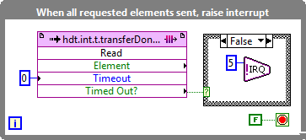
Figure 32 When all requested elements sent, raise interrupt

Transfer background to host
When the background data is transferred to DMA FIFO, IRQ 4 is raised. This interrupt is used on host side to get acknowledged for the correct data stream.
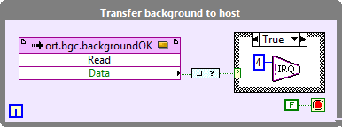
Figure 33 Transfer background to host

Host data averaging
This loop prepares the pixel data of image channels and bundles it into FIFO named outBundle. Averaging all data between two consecutive pixel event flags (se-hdt.t.pixelEvent) is possible (hdt.p.mainAverageChannelsEnabled). outBundle is an array of 8 image channels. The first two are Height and Error. These channels are fixed but the remaining six channels can be selected between various options through the hdt.int.s.AISource array, which defines which other six channels are selected from the following options: AI0-7, ORT interaction approach slope (fb-hdt.t.fwdSlope), ORT interaction retract slope (fb-hdt.t.bwdSlope), ORT interaction retract min (fb-hdt.t.minBwd), ORT interaction dissipation (fb-hdt.t.Dissipation), tapping mode magnitude (lia.hdt.mag), tapping mode phase (lia.phase), auxiliary input (outAuxIn).
Figure 34 Host data averaging

Host data transfer main
Selected image channel pixel data is sent via DMA FIFO (hdt.t2h.mainStream) to host. outBundle stores an array of 8 elements for a pixel. Elements of this array is written on hdt.t2h.mainStream one by one.
Figure 35 Host data transfer main

Aux inputs recording and passover to averaging
Figure 36 Aux inputs recording and passover to averaging
aio-hdt.aux has AI4-7. 3 free channels are added and total 8 channels are written into inBundleAux. This data is fed into aux data transfer channel for host transfer.

Aux inputs averaging and pixel synchronous output
Figure 37 Aux inputs averaging and pixel synchronous output
inBundleAux FIFO is synched to pixel event and averaged on demand. Then written into outBundleAux.

Aux bundle to host
Figure 38 Aux bundle to host
outBundleAux FIFO is transferred to host via DMA FIFO hdt.t2h.auxStream.

Memory write access for scan engine
Memory blocks regarding to the scan engine is filled in this while loop. se.fastAxis , se.slowAxis , contain the data for the coarse waveform for slow and fast signals (x and y).
These memory blocks are read in the scan engine to interpolate.

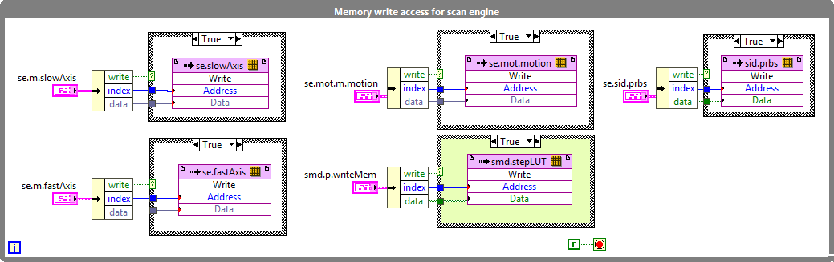
Figure 39 Memory write access for scan engine

scan loop
There are two general modes of working in the scan engine: scanning, moving. Scanning refers to the case when the scan engine sends the triangular and ramp signals to the output (when the AFM is scanning the surface) and moving refers to the case when the scan engine prepares the signal such that the scanner moves to a specific position.
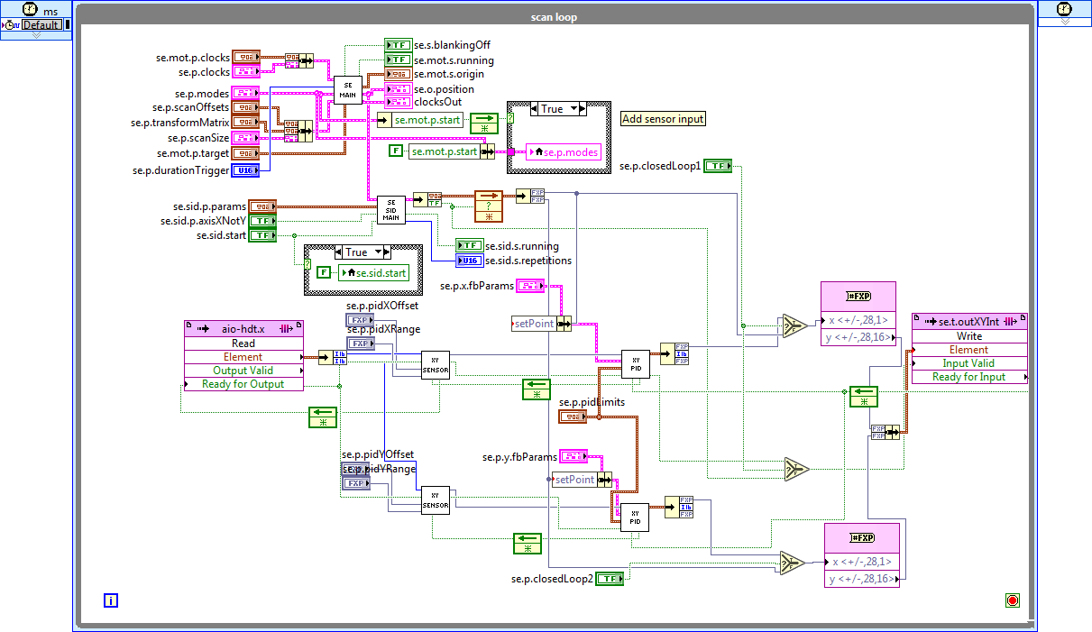
Figure 40 scan loop
The signal sent from the host to the scan loop in FPGA, has the main shape of the signals with a limited number of points. The scan loop generates the output signal in the form of fine signal by interpolating between the points that it has received from host and later offsetting and scaling those generated points. The main goal is to generate the signal with as many points as possible (the I/O rate).
Moreover, while preparing the outputs signal, it checks the current point that it is preparing and enables several FIFOs based on the predefined conditions such as pixel event, end of line, end of frame. These FIFOs are used outside the scan engine to create the images.
Host
FPGA
(scan engine)
AO0 AO1
Coarse signals
Fine signals
Image details FIFOs
Figure 41 The connections between Host, Target, and Outputs for performing the scan process

Figure 42 The interpolation process for two consecutive points on the memory block (generating fine points between two points of the coarse waveform)
Figure 42 shows the process performed between two consecutive points of the memory block which is done for all the three memory blocks (se.motmotion, se.fastAxis, se.slowAxis)
The outputs of this interpolation are sent to a block to apply the scan size, rotation, and offset changes.
First, the interpolated data is scaled using the data taken from the host (fastScanSize, slowScanSize) and in case of inverting the scan direction (InvertSlowAxis) the slow scan signal is inverted. In the next step the values produced for x and y are multiplied by the rotation matrix to give the rotated values (outputMatrix is the bundle that contains a, b, c, d). In the final step, the generated values are added to the offset values for x and y (scanOffset is the bundle that contains offsets for x and y).
While creating the fine output signal, the scan engine checks the memory block that it is reading and if it reaches specific indices; such as pixel event, end of line, end of frame, it has to validate the input of several FIFOs. These FIFOs are Booleans that are fed with true. The FIFOs are used to create the images in other parts of the FPGA code.
FIFOs:
- se.t.endOfFrame.Trigger: It goes to output channel EndOfLine. Refer to se.p.durationTrigger (input variable to Scan Engine). It goes high at the end of the slow waveform period and stays high for se.p.durationTrigger clock ticks.
- se.t.endOfLine: It is enabled when the se.p.enable is true and the scan engine has reached the end of one fast waveform period.
- se.t.endOfFrame: It is enabled when the se.p.enable is true and the scan engine has reached the end of the slow waveform period.
- hdt.t.mainStreamClear: A Boolean that is used to dump the not useful data that is collected while the scan engine is going through the blanking parts or during the manual motion. It should be enabled just after fb1 and fb3 are finished. So, it flushes the data that has been collected during the non-image part, which is either blanking or other motions.
- se-hdt.t.pixelEvent: FIFOs that get true when the scan engine has gone through the given number of ticks per pixel. Please note that it does not generate true when it is in the blanking region (the round parts that are not used for the image)
- se-dio.t.pixelEvent: FIFOs that get true when the scan engine has gone through the given number of ticks per pixel. Please note that it does not generate true when it is in the blanking region (the round parts that are not used for the image)
- se-hdt.t.pixelEventAux: FIFOs that get true when the scan engine has gone through the given number of ticks per pixel. Please note that it does not generate true when it is in the blanking region (the round parts that are not used for the image)
Memory blocks:
- se.fastAxis: Written on in the “Memory write access for scan engine” loop. Data is taken from the variable called se.m.fastAxis which is a cluster of three elements: write (Boolean), index (memory address), Data (data). This variable (se.m.fastAxis) is generated in Host VI called Scan.vi in the event called: ScanWaveform.Send. This contains the coarse waveform that is generated in the host for the fast axis (X).
- se.slowAxis: Written on in the “Memory write access for scan engine” loop. Data is taken from the variable se.m.slowAxis which is a cluster of three elements: write (Boolean), index (memory address), Data (data). This variable (se.m.slowAxis) is generated in Host VI called Scan.vi in the event called: ScanWaveform.Send. This contains the coarse waveform that is generated in the host for the slow axis (Y)
- se.mot.motion: Written from the variable called se.mot.m.motion. Memory access node for the waveform that is replayed when moving manually. (constant acceleration s-shape).
- se.mot.running: This is also written on the variable se.mot.s.running. This is the memory that indicates whether there is a manual motion on the scan engine or not.

Automatic background correct request
Based on the end of frame or end of line flags of se_main.vi, background correct request can be sent automatically in this loop. Controller to select automatic background correct mode is called ort.bgc.requestType and 0, 1, 2 correspond to never, end of line, end of frame.
Figure 43 Automatic background correct request

Triggers End of Line / Frame
This loop sends beginning of frame, end of line, and end of frame flags to digital outputs of the FPGA. Names of carrier FIFOs are: se.p.beginningOfFrame, se.t.endOfLine.Trig, se.t.endOfFrameTrigger.
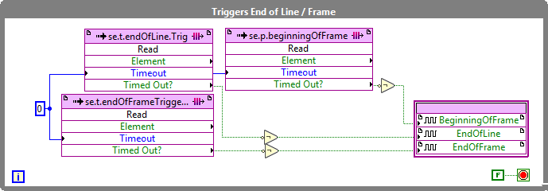
Figure 44 Triggers End of Line / Frame

Trigger pixel
This loop generates pulses of 500 ns (20*1/(40 MHz)) after every pixel event. Pixel event is carried by FIFO named, se-dio.t.pixelEvent.
Figure 45 Trigger pixel

Write a Sawtooth Waveform to 3 FIFOs (Stick-Slip)
This loop generates configurable 3 channels sawtooth waveform for control of X, Y, Z stages of three axis stick-slip positioner. Filled FIFOs are transferred to AO5, AO6, AO7.
Figure 46 Write a Sawtooth Waveform to 3 FIFOs (Stick-Slip)

SPI Comm Loop
SPI communication protocol is implemented here. Based on event structure actions related FIFOs are filled and then processed in SPI.vi in parallel
Figure 47 SPI Comm Loop
Contents
Populate memory items for feedback from host 1
AIO settings 1
Analog inputs acquisition 1
Analog inputs sorting 2
x-y physical output 3
Slow host-controlled signal generator 3
Height and excitation output 3
Fast ADC DAC interface 4
Input module acquisition and excitation output 4
ORT Mode 6
AM mode 9
Contact mode average 10
ORT mode excitation generator 11
Main process variable selection 11
PID calculation and height control 12
Retract on background correct to get non-interact background 16
z Watchdog for auto-approach 16
Coarse Z control 17
Host data transfer interaction wave generator and memory control 17
Transfer interaction data to host 17
When all requested elements sent, raise interrupt 18
Transfer background to host 18
Host data averaging 18
Host data transfer main 19
Aux inputs recording and passover to averaging 19
Aux inputs averaging and pixel synchronous output 20
Aux bundle to host 20
Memory write access for scan engine 20
scan loop 21
Automatic background correct request 24
Triggers End of Line / Frame 24
Trigger pixel 24
Write a Sawtooth Waveform to 3 FIFOs (Stick-Slip) 25
SPI Comm Loop 25

